**Your child could lose up to three month’s worth of reading progress in one summer. You can help defeat this loss by spending time reading with your child.**

* Help defeat summer reading loss by :
* Providing reading opportunities daily
* Reading a variety of materials, such as books, internet sites, magazines, and etc.
* Discuss the reading by asking questions and sharing
* Encouraging your child to write or draw a response to what they have read

Taken from JustReadFlorida

C:\Documents and Settings\TEMP\Local Settings\Temporary Internet Files\Content.IE5\ANMJMDC9\MC900134551[1].WMF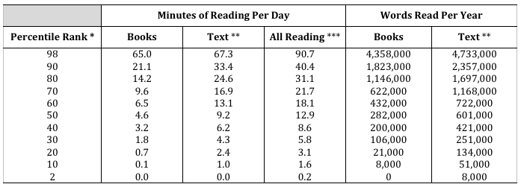

Chart from:

Anderson, R. C., Wilson, P. T., & Fielding, L. G. (1988). Growth in reading and how children spend their time outside of school. Reading Research Quarterly, 23, 285-‐303.

**Online Ebook Resources**

**Broward County Public Library**

<http://broward.lib.overdrive.com/91B185F69F98476591C978C4AFBB04CB/10/415/en/SearchResults.htm>?

**Tumblebooks Broward Schools**

<http://www.tumblebooks.com/library/asp/home_tumblebooks.asp>

**Oxford Owl Ages 3 -7**

<http://www.oxfordowl.co.uk/Library/Index/>?AgeGroup=4

**Free Audio Books List of Annotated Resources**

**K-12**

<http://www.teachersfirst.com/spectopics/audiobooks.cfm>

**Project Gutenberg**

<http://www.gutenberg.org/wiki/Main_Page>

**Free iPad Reading Apps for Kids**

**Available through iTunes**

  

Read to me A Story Before Bed 100 Ways to Get Your Child to Read

  

MeeGenius Toy Story International Children’s Digital Library

**Reading Activity Websites K -5**

**Between the Lions** Read along as you play games and watch videos of books.

<http://pbskids.org/lions/index.html>

**Carol Hurst’s Children’s Literature** Children’s Book Reviews by grade

<http://www.booksintheclassroom.com/allreviewed.php>

**Starfall** Online resource to teach children to read with phonics

<http://www.starfall.com/>

**Storybird** Create illustrated stories by yourself or with your family or friends.

You can also read stories by other kids.

<http://storybird.com>

**Mightybook.com View**

For kids ages 2-12 years, read-aloud stories that kids can listen & read along with.

<http://www.mightybook.com/>

**Reading Rockets** Recommended books for parents and educators on reading development and instruction.

<http://www.readingrockets.org/resourceinfo/booksresources>

**Summer Travel Activities**

http://fun.familyeducation.com/travel/family-travel/33401.html Explore games, activities and crafts for children.

**Summer Time Reading** - Parent resource http://www.rif.org/documents/us/summer_reading.pdf

**Just Read, Florida!** The Just Read, Florida! site provides a list of suggested summer reading selections as well as tips for helping children with reading skills at home. http://www.justreadflorida.com

**Just Read, Families!** http://www.justreadfamilies.org/

**Sunshine State Young Reader Awards** The Sunshine State Young Reader’s Award Program is a statewide reading motivation program for students in grades 3-8. http://myssyra.org